**President Ghani’s Endeavours**

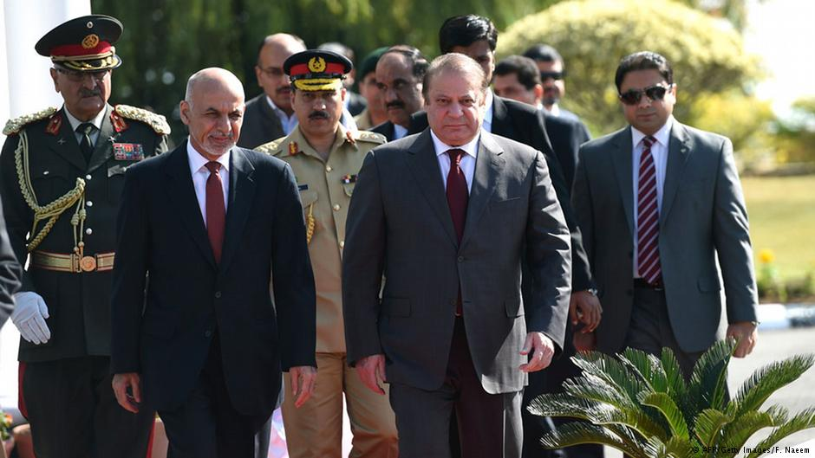

Afghan President Ashraf Ghani’s visit to Pakistan is being viewed with optimism and this could be a new beginning for the two countries. It was President Ghani’s first visit to Pakistan after assuming office this September. Since the new Afghan government took office, a number of high-ranking Pak officials, including National Security and Foreign Affairs Adviser, COAS and DG ISI have visited Kabul. President Ghani during his interaction with the politico-military establishment of Pakistan discussed the ways of countering terrorism. He called for security ties and cooperation in border management.

The event of 9/11 impacted the world politics in general and the Pak-Afghan region in particular. World players got united against the menace of terrorism. Attacks were launched in Afghanistan to dismantle the Al-Qaeda stronghold in the country. Pakistan being the neighbouring Afghan country faced the maximum fallouts of the war. Nearly, 50, 000 Pakistanis were killed in the terrorist attacks and still the country is battling the terrorists. The Pak-Afghan relations suffered badly and insinuations of mistrust nourished. Hostile forces exploited the situation to their advantage, in particular, India under the garb of War on Terror (WoT) reinforced its ingress in Afghanistan. India tried to discredit Pakistan’s efforts in the fight against terrorism. Afghan government also accused Pakistan of playing a dubious game and sponsoring radicalism. Government of Pakistan after the launch of operation ‘Zarb-e-Azam’ in North Waziristan requested the Afghan government to beef up security on its side of the border. The aim was to prevent militants fleeing from Pakistan to enter Afghanistan. The response received from the Afghan side was “both sides would have to sincerely take action against the terrorists and militants on their side of the border to tackle militancy and terrorism”. In another interview with the BBC, former Afghan President Karzai said “the war on terror being waged by the US led NATO forces for more than a decade in Afghanistan should have been fought outside his country’s borders and not in Afghan villages and homes”.

Unlike his predecessor, President Ghani sees cordial relations with Islamabad vital for regional peace. The current high-level interaction between the Pakistan and Afghan leadership indicates improvement of ties. It appears that both the sides well aware of each other’s importance want to re-build the trust and start a new beginning. Ghani’s interaction and meetings with military officials will strengthen Afghanistan’s confidence in sharing intelligence information along the Pak-Afghan border. The Pakistan army has also offered to train the Afghan soldiers and enhance the capacity building of Afghan National Security Force (ANSF). There are speculations that under the new Afghan leadership, the Pak-Afghan relations are likely to improve and the mistrust created between the two neighbours during the WoT is likely to recede. President Ghani’s recent interaction with the politico-military leadership of Pakistan is likely to build the required trust between the two neighbours, gather enough strength to emphasize Pakistan’s usefulness for Afghanistan and highlight the difficulties particularly for the Pashtuns living on both sides of the border. However, if unnecessary obstacles are created in the way to please India, it will add to the sufferings of people of both Pakistan and Afghanistan.

President Ghani had also undertaken a visit to Saudi Arabia and China. In Beijing, Ghani stated, “peace is our highest priority”. He called for an inter-Afghan peace dialogue with Taliban. A US-led negotiation process with the Taliban failed in Qatar last year. China also offered a peace and reconciliation forum to bring the two sides together. China being the leading foreign investor in Afghanistan, supports a peaceful/stable Afghanistan. Chinese investment in Afghanistan include US $ 3 billion in the East (Aynak copper mine), and about US $ 700 million in the North (oil and gas exploration rights). An insecure Afghanistan could also be an impediment to the Chinese economic vision “New Silk Road”, that will connect Western China to Northern Europe, passing through Central Asia, Middle East and Turkey. Apart from the economic aspect, China fears that a Taliban stronghold in Afghanistan could embolden the Chinese Uighur population in the Xinjiang province.

In post-2014, a limited number of foreign troops (12000-13000 approximately) would be stationed in Afghanistan (under the Bilateral Security Agreement-BSA), and the prime responsibility of the security would lie on the ANSF (strength 350,000). To tackle the Taliban insurgents and to revive the war torn economy, the country requires outside support. The new government’s move to re-orient Kabul’s ties with the outside world are steps in this direction. In this endeavour, Kabul’s ties with Islamabad are crucial but Ghani must convince the have-nots around him or those with vested/personal interest.

**Amna Ejaz Rafi**

**Islamabad Policy Research Institute (IPRI)**