

**Fall of Assad Regime: Possible Scenarios for Syria’s Future**



**December 2024**

**Ali Hamza**

**Research & Analysis Branch**

**EXECUTIVE SUMMARY**

**Fall of Assad Regime: Possible Scenarios for Syria’s Future**

The opposition forces, comprising diverse factions backed by various regional and international powers, have taken control of Damascus after a swift offensive against the Assad regime. The events mark a decisive moment in a years-long civil war. While global consensus exists for an inclusive and democratic political arrangement, diverging interests of stakeholders hinder progress toward such a transition.

Historically, Syria has lacked experience with democratic governance, with the Assad family's secular authoritarian rule dominating since 1970. Despite calls for democratization, such as the Geneva Communique of 2012 and UNSC Resolution 2254, practical efforts remain absent. Iran and Russia, allies of Assad, resisted democratization, while countries like the United States and Turkey have pursued their own interests. The U.S. backs the Syrian Democratic Forces (SDF) to counter ISIS and Iran but faces tensions with Turkey, which opposes the SDF's Kurdish affiliations. Meanwhile, Arab monarchies, despite opposing Assad, are unlikely to advocate for democracy given their domestic political contexts.

The opposition’s ability to implement democracy depends on uniting its factions, including Hayat Tahrir al-Sham (HTS), which has sought to moderate its stance post-Al-Qaeda affiliation. However, integrating minority groups and rival factions, such as the SDF and Turkish-supported Syrian National Army (SNA), remains challenging. Without credible steps toward democracy, thesituation in the country will be fluid, especially when armed rival groupsand their international patrons may struggle for greater share in the pie. The ensuing instability risks reigniting ISIS activities and escalating sectarian violence.

While global powers endorse peace and democracy in Syria, conflicting interests and the fragmented opposition present formidable obstacles. A failure to establish a democratic power-sharing framework may perpetuate Syria's civil conflict, deepening the humanitarian and political crisis.

Overall, the US, Turkiye, Israel, and Saudi Arabia have gained upper hand in the post Assad situation in Syria, while Iran and Russia have to incur the setbacks. It is also a setback to China which entered into a strategic agreement with the Assad regime after the eruption of unrest in the country.

**Key Words:** Democratization, Opposition forces, Sectarian violence, Civil war, Geopolitical interests, Power transition

**Fall of Assad Regime: Possible Scenarios for Syria’s Future**

**Issue**

The policy brief aims to analyze the repercussions of the fall of Assad regime in Syria and the ensuing uncertainty over the future of Syria’s political outlook. As the opposition forces are composed of various factions supported by different regional and international political actors, their intentions and ambitions will define the political and security architecture. Despite the widespread acceptance of an inclusive and democratic political arrangement for peace in Syria by all actors involved, the diverging interests of global powers can act as a hurdle for democratic power sharing. There is a fear of country plunging into civil war again.

**Analysis**

In a surprising series of events, the opposition groups in Syria have taken over the capital, which lasted for less than two weeks forcing President Assad to flee the country. As the opposition forces, led by Ha’yat Tahrir Al-Sham (HTS) took over the capital Damascus in their lightening offensive, the shock and awe around the world persists. Sudden fall of Assad regime has given room to various speculations, including President Assad’s tacit deal with the opposition groups, and the revival of ISIS/Daesh rule in the country. As the events unfold in the country, it is yet to be seen if the recent events forge a different Syria politically and socially, or it plunges further into chaos.

The fall of Assad’s regime is the culmination of the Syrian Civil War that started in 2011 after the ruling regime brutally clamped down on agitation against Assad’s authoritarian rule. Inspired by the Arab Spring, Syrians demanded democracy and reforms in the country. They were met by iron-fisted response by the regime and soon the country plunged into civil war. Taking the shape of armed resistance against the Assad regime, the opposition forces established control over large swathes of the country initially, but were pushed back by the government forces with the help of Iran and Russia. The opposition forces comprising of various groups and factions with support from respective regional and international actors including Turkiye, United States of America, United Arab Emirates, Saudi Arabia, and other regional and international actors actively participated in countering Assad’s forces. The future of Syria will be shaped by the Syrian opposition forces and their international supporters. Therefore, various probable scenarios can be discernable in the future.

**Is a Democratic Transition Possible?**

Syria has had a history of continuous coups. After Hafez Al-Assad rose to power in Syria as a result of a coup against Salah Jadid, the de facto leader of Syria, the country has been ruled by the same family. Although belonging to the Alawite Shi’a sect, Assad’s ruled a Sunni majority Syria. However, the Assad regime followed a secular polity.

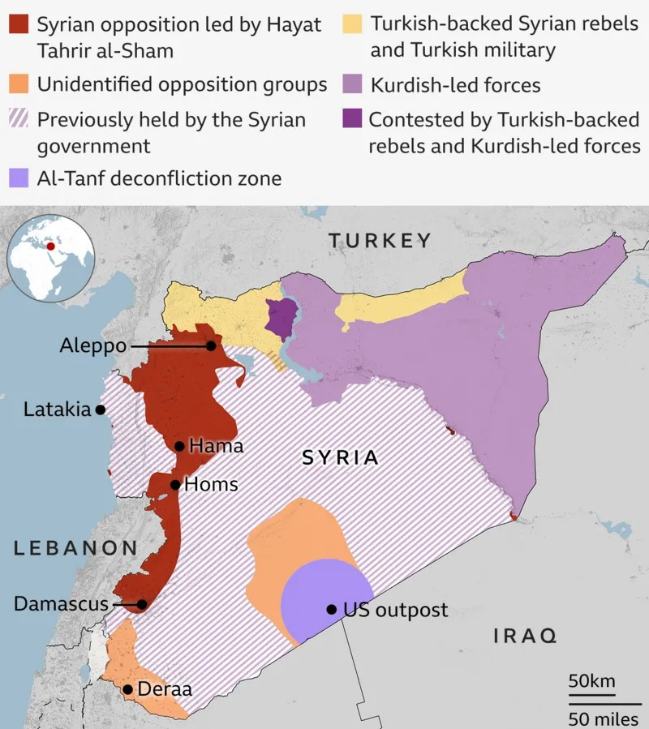As Syria’s experience with a democratic form of government has been negligible, the transition to such a form of government will be complex. At the highest international forums, the cure for all the ills of Syria has been prescribed as an inclusive, Syrian-led, democratic government in Syria. The Geneva Communique of 2012 clearly mentions that for sustainable peace, the Syrian state must be “genuinely democratic and pluralistic” and it must “give space to established and newly emerging political actors to compete fairly and equally in elections.”[1] The communique also requires the Syrian state to comply with international standards on human rights, the independence of the judiciary, accountability of those in Government and the rule of law. This is a clear indication that a genuinely democratic form of government for Syria was proposed as a solution to the conflict as soon as the conflict began. The frequently discussed United Nations Security Council Resolution 2254 (2015) completely endorses the Geneva Communique. This resolution was adopted by the UNSC at its 7588th meeting in 2015, and was supported by all the major actors with their stakes in Syria.[2]

Despite the stress on democratic transition in Syria for a sustainable and peaceful settlement to the conflict, any attempts towards this end have been absent. Iran and Russia, the strongest allies of the Assad regime never supported the transition effectively as their interests were aligned with the regime. The United States and Turkiye also supported their respective opposition groups fighting against the regime and among themselves as well. The Syrian Democratic Forces (SDF), supported by the US is designated a terrorist organization by Turkiye due to its proximity with the dissident Turkish Kurds. Turkiye is concerned by the ambitions of SDF to forge a Syrian-Turkish independent entity on the Syria-Turkiye border.[3] Its focus has, thus, remained on containing the SDF. Turkiye might have been dubbed as a “winner” apparently as the Assad regime fell, but the challneges for Turkiye have multiplied with opposition forces’ victory. Therefore, Turkiye will have a major political as well as military involvement in the country,[4] which will not be necessarily supportive of an inclusive and democratic transition for Syria as it can embolden SDF in the north.

The major stake of the US in Syria has been the containment of Iranian influence and defeating ISIS. For this purpose, the US has provided support in the form of weapons and training to the SDF as well as it has also stationed about 900 US soldiers on ground in Syria.[5] As president Trump stresses the need for avoiding interference in conflicts around the world and his “hands-off” approach for Syria, it is clear that US will focus on its primary objectives and would only pay lip service for efforts for a democratic transition in the country.[6] The Arab kingdoms have also opposed the Assad regime vehemently, but after his removal, it is yet to be seen if these monarchies can support any attempts for democratization. Qatar, UAE, and Saudi Arabia have considerable influence in Syria, but their own regimes have felt the heat of the Arab Spring. Therefore, it is less probable for them to support democratization efforts in Syria. Earlier considered to be highly supportive of Sunni Islamist groups, Saudi Arabia under Muhammad bin Suleiman is transitioning into a modern and progressive state. Thus, its support to Ha’yat Tahiri Al-Sham (HTS) or other Sunni groups based on Sunni affinity is unlikely.

Iran and Russia are undoubtedly the losers in the scenario. As their ally faced a humiliating defeat and fled the country, the long-standing support for the regime has subjected both of these states to be dubbed as enemies by the opposition. Whether it was the merciless aerial campaign by Assad or the use of chemical weapons, Iran and Russia stood by him. China also supported Assad regime at the UN Security Council. This has left little space for these states to engage with the opposition forces in Syria. Iran has also lost the essential territorial link it had with Lebanese Hezbollah through Syria, and its embassy in Damascus was ransacked.[7] Russia still has its air bases in the Alawite majority coastal regions in Syria. These regions have not yet faced any opposition forces’ onslaught. Both of these states having their influence of the Assad’s predominantly Shi’a supporters can play their hand for pushing a democratic transition, a dynamic both states lack domestically in the eyes of the West. If Iranian-backed Shi’a militia, like the Iraqi Badr, Nujabaa, and Kataib Hezbollah who have been aiding Assad’s forces, confront the opposition forces, there can be a spiraling of sectarian violence across the country. Israel appears to be least interested in the internal 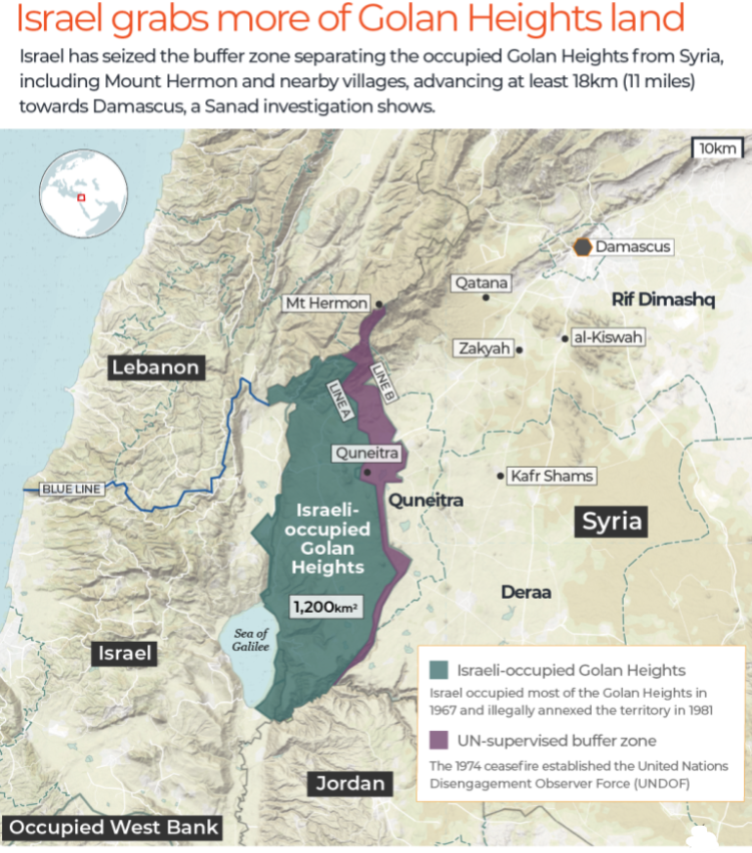dynamics of post-Assad Syria as the anti-Israel regime has fallen. It cannot and will not play any part in stabilization and democratization of Syria, but its actions in the Golan Heights and elsewhere in Syria will have a destabilizing effect. Till the time of writing, Israel had carried out more than 400 air strikes in Syria on different targets, along with the air strikes from the US.[8] It has reportedly crossed the buffer zone in the Golan Heights and incursions into to other parts in Southwest of Syria are also reported.[9] The continued violation of Syria’s sovereignty by Israel and its warped manifestation of self-defense in Golan Heights makes Israel an agent of instability in Syria.

*Source: Al-Jazeera*

Finally and most importantly, any prospects of democracy in Syria depend on the opposition forces’ intent and capacity. Most important faction in the opposition forces is the Hayat Tahrir Al-Sham (HTS), a previously Al-Qaeda affiliated group. Its own credentials are those of a terrorist organization for the world. However, after severing its ties with Al-Qaeda in 2016, HTS has tried to tone-down its extremist outlook and has made attempts to be made more palatable for the Syrian minorities. During their lightening offensive, HTS has not attacked any minority group yet. In fact, they have made attempts to allay concerns of Shi’a and Christian minorities by keeping them safe during their offensive. Professor Hind Kabawat, Director of the Carter School for Peace and Conflict Resolution at George Mason University quotes the Christians of Aleppo being treated quite well by the HTS led forces.[10]

The challenge for a terrorist-designated group like HTS will be to form an inclusive arrangement where all opposition groups participate to chalk-out Syria’s political future. The Christian and Shi’a minorities; opposition forces like Ahrar Al-Sham and National Front for Liberation (NFL); as well as groups like Turkish-supported Syrian National Army (SNA) and US-supported Syrian Democratic Front (SDF) will demand substantive representation in any future political arrangement. In the presence of all these actors, free elections and resultant democratic transition would be a fall order in Syria.

**Continuation of Civil War**

If credible attempts for democracy and peace in Syria are not made by all the stakeholders, the civil war will essentially continue unabated. Such a scenario might look bleak for those expecting the fall of Assad regime to bring a bright future for Syrians, but it is important to note that the reality on ground in Syria is that the status quo is a mix of various factions fighting the regime at some places, and fighting each other. Thus, averting the continuation of civil war remains a daunting task.

As the Turkiye and the US support opposing groups in the Northern parts of Syria, this fighting can intensify given that both groups will now also compete for influence in the future political arrangements in Syria. Clashes have already broken out between Turkish-backed forces and SDF in northern city of Manbij for establishing control in the region.[11] Iran’s response has been cautious for now, but any attempts to cultivate its assets in Syria in the form of Shi’a militants will lead to sectarian violence. ISIS has been neutralized to a large extent, if the civil war intensifies, it can raise its head again in the country, especially in Syria.

1. “Final Communiqué of the Action Group for Syria (Geneva Communiqué) | UN Peacemaker,” 04, accessed December 10, 2024, https://peacemaker.un.org/node/9026.
2. “Security Council Unanimously Adopts Resolution 2254 (2015), Endorsing Road Map for Peace Process in Syria, Setting Timetable for Talks | Meetings Coverage and Press Releases,” accessed December 10, 2024, https://press.un.org/en/2015/sc12171.doc.htm.
3. Henry J. Barkey, “What Role Is Turkey Playing in Syria’s Civil War? | Council on Foreign Relations,” Council on Foreign Relations, December 6, 2024, https://www.cfr.org/expert-brief/what-role-turkey-playing-syrias-civil-war.
4. Lyse Doucet, “HTS Leader Not Only Player in Syria’s Fast-Changing Future,” BBC, December 8, 2024, https://www.bbc.com/news/articles/c0kv582lpnro.
5. Jake Johnson, “Roughly 900 US Troops Still in Syria as Rebels Close in on Damascus | Common Dreams,” Common Dreams, December 7, 2024, https://www.commondreams.org/news/us-troops-in-syria.
6. Stephen Collinson, “Trump Has Big Plans at Home, but Syria Shows Why He Can’t Escape the World’s Problems | CNN Politics,” CNN, December 9, 2024, https://www.cnn.com/2024/12/09/politics/trump-syria-analysis/index.html.
7. Bruce Hoffman, “Syria After Assad: What to Know About HTS, Hezbollah, and Iran | Council on Foreign Relations,” Council on Foreign Relations, December 9, 2024, https://www.cfr.org/expert-brief/syria-after-assad-what-know-about-hts-hezbollah-and-iran.
8. “Barrage of Israeli Attacks Destroys ‘Important Military Sites in Syria’ | Syria’s War News | Al Jazeera,” accessed December 10, 2024, https://www.aljazeera.com/news/2024/12/10/barrage-of-israeli-attacks-destroys-important-military-sites-in-syria.
9. “Israel Expands Military Presence in Syria, Seizes Buffer Zone and Targets Key Sites,” accessed December 11, 2024, https://tribune.com.pk/story/2515000/collapse-of-assads-government-fuels-israeli-occupation-and-strikes-on-syria.
10. Dareen Abughaida, “How Will Syria Be Governed after the Fall of Al-Assad’s Regime?,” The Inside Story Podcast, accessed December 10, 2024, https://play.headliner.app/podcast/_cpf_cl26fdw930000ejqk7xrtfurn/episode/8c2ed118-d8f7-4734-9613-b24000fa0ea4?dtm_campaign=WI_cktj3ghn6000012oldnw5chzg_DV_cl1w8nhac00000xrz2nhhgw1j&dtm_content=Result1&dtm_medium=CPC&dtm_source=DiscoWidget&utm_campaign=WI_cktj3ghn6000012oldnw5chzg_DV_cl1w8nhac00000xrz2nhhgw1j&utm_content=Result1&utm_medium=CPC&utm_source=DiscoWidget.
11. “Syria in Maps: Who Controls the Country Now Assad Has Gone?,” accessed December 11, 2024, https://www.bbc.com/news/articles/c2ex7ek9pyeo.